Chapter 8 Thermochemistry name: class:
考点 A: 热量传递 Heat Transfer
1. 温度高的物体粒子平均动能更大
2. 热传递通过热接触的粒子碰撞实现
3. 热平衡：两物体粒子平均动能最终相等，温度相同
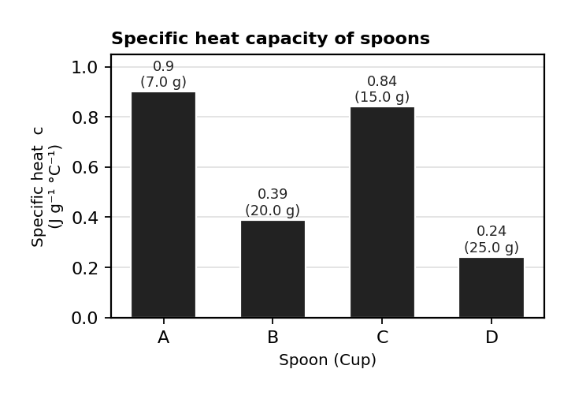
图 C₀8-3：四种勺子的比热容对比（对应考点 A MCQ1）

1. CupSpecific heat capacity of spoon (J / g oC)Mass of spoon (g)Initial temperature of spoon (oC)A0.907.020B0.3920.020C0.8415.020D0.2425.020 Four identical 300 mL cups of fresh brewed coffee, originally at 91 °C, were stirred with different spoons, as listed in the table above.
In which cup will the temperature of the coffee be highest at thermal equilibrium? (Assume that the heat lost to the surroundings is negligible.) （ ）
A. Cup A (black surface, best absorber and radiator, cools fastest)
B. Option B
C. Option C
D. Option D

2. What is meant by thermal equilibrium? （ ）
A. Two bodies have the same kinetic energy but their temperature is different.
B. Two bodies have different kinetic energy so their temperature is different.
C. Two bodies have the same kinetic energy so their temperature is the same.
D. Two bodies have different kinetic energy but their temperature is the same.

3. A metal spoon is placed in a cup of hot coffee. Which statement best describes the heat transfer process? （ ）
A. Heat flows from the spoon to the coffee until they reach the same temperature.
B. Heat flows from the coffee to the spoon until they reach the same temperature.
C. The spoon heats up but does not affect the temperature of the coffee.
D. No heat transfer occurs because metals are good conductors.

4. A student has two beakers containing water at two different temperatures.
Beaker 1 contains 300 g of water at 40oC.
Beaker 2 contains 100 g of water at 80oC.
Which of the following statements is true? （ ）
A. Beaker 2 contains water particles with higher average kinetic energy than beaker 1.
B. The water in beaker 1 has a higher specific heat capacity than beaker 2.
C. Beaker 2 has a higher thermal energy than beaker 1.
D. On mixing the two beakers, the final temperature of the water would be 60oC.

考点 B: 能量变化 Energy Change
1. 吸热过程 (Endothermic) vs 放热过程 (Exothermic)
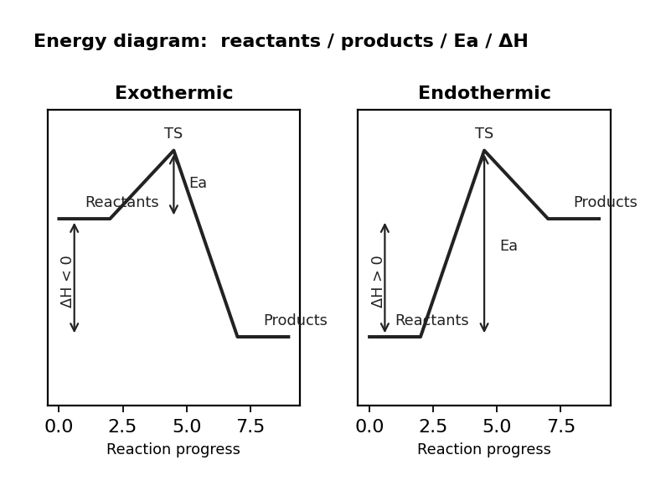
图 C₀8-1：放热与吸热反应能量图（对应考点 B 能量变化 / MCQ5）
2. 放热反应：产物能量 < 反应物能量，释放热到环境；吸热反应反之（用能量图表示）
3. 溶解过程的热效应取决于溶解前后分子间/粒子间作用的相对强弱

1. Which of the following phase changes would result in the greatest increase in the potential energy of the system? （ ）
A. Condensation of steam.
B. Option B
C. Sublimation of dry ice (solid CO₂).
D. Vaporization of water.

2. During a phase change, which of the following statements is true regarding the kinetic and potential energies of the particles? （ ）
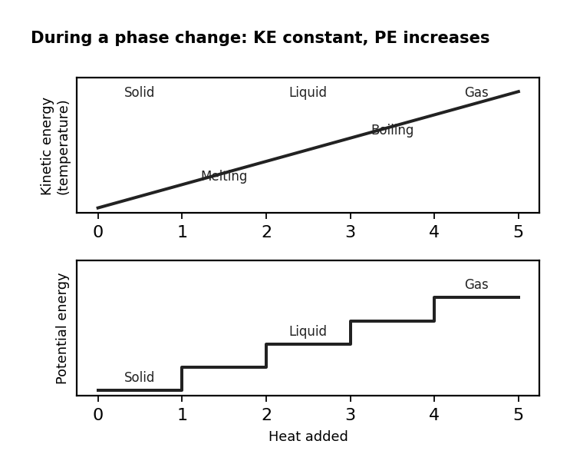
图 C₀8-2：相变过程中的动能与势能变化（对应考点 B 相变能量 / MCQ2）
A. Both kinetic and potential energies increase.
B. Kinetic energy remains constant while potential energy increases.
C. Kinetic energy increases while potential energy remains constant.
D. Both kinetic and potential energies remain constant.

3. Which of the following phase changes involves the largest increase in the potential energy of the system? （ ）
A. Option A
B. Evaporating 10 g of water.
C. Sublimating 10 g of dry ice.
D. Freezing 10 g of water.

4. Which of the following best explains why the reactions represented in the table are exothermic?
Balanced equation for the combustion of one mole of the compoundΔHoc(kJ/mol )C₂H₆ (g)+ 3.5 O₂ (g) → 2CO₂ (g) + 3H₂O (l)-1560C₃H₈ (g)+ 4.5 O₂ (g) → 3CO₂ (g) + 4H₂O (l)-2020 （ ）
A. The energy released in forming the bonds in the products is less than the energy required to break the bonds in the reactants.
B. The energy released in forming the bonds in the products is more than the energy required to break the bonds in the reactants.
C. The number of bonds in the product molecules is less than the number of bonds in the reactant molecules.
D. The number of bonds in the product molecules is more than the number of bonds in the reactant molecules.

5. Which statement about energy diagrams is correct? （ ）
A. An energy diagram for an exothermic reaction has the reactants at higher energy than the products with a positive enthalpy change.
B. An energy diagram for an endothermic reaction has the reactants at lower energy than the products with a positive enthalpy change.
C. An energy diagram for an exothermic reaction has the reactants at lower energy than the products with a negative enthalpy change.
D. An energy diagram for an endothermic reaction has the reactants at lower energy than the products with a negative enthalpy change.

6. Ammonium chloride dissolves endothermically. What type of energy conversion takes place? （ ）
A. Chemical energy to kinetic energy
B. Kinetic energy to chemical energy
C. Kinetic energy to potential energy
D. Potential energy to chemical energy

7. In the energy diagram shown above, （ ）
A. ΔH is exothermic and the forward activation energy is greater than the reverse activation energy
B. ΔH is endothermic and the reverse activation energy is greater than the forward activation energy
C. ΔH is exothermic and the reverse activation energy is greater than the forward activation energy
D. ΔH is endothermic and the forward activation energy is greater than the reverse activation energy

8. The diagram above shows the heating curve for a substance. Determine which of the following statements is true? （ ）
A. The specific heat capacities of the three states of matter are approximately the same.
B. The enthalpy of fusion is less than the enthalpy of vaporization.
C. The specific heat capacity of the gas is greater than the enthalpy of fusion.
D. The specific heat capacity of the gas is greater than that of the liquid.

9. The diagram above represents a heating curve for a typical substance.
Iodine is a solid that sublimes very easily.
Which statement would be true about the heating curve for iodine compared to the one above? （ ）
A. Line B would rise and become closer to the level of line D.
B. Line C would be shorter and steeper.
C. Line C would disappear and B and D would be at the same level.
D. Line D would become much shorter than line B.

考点 C: 量热法 Calorimetry
1. 掌握量热法 q = mcΔT
Coffee-cup calorimeter: q_solution = mcΔT (where m = total mass of solution)
q_reaction = −q_solution (conservation of energy)
Endothermic: T decreases (system absorbs heat); Exothermic: T increases (system releases heat)

1. Which of the following statements best explains why water takes longer to heat up than most metals when the same amount of heat energy is applied? （ ）
A. Water is a liquid, and metals are solids.
B. Water has a higher specific heat capacity than most metals.
C. Water molecules form hydrogen bonds that absorb heat energy.
D. Water has a higher density than most metals.

2. Which of the following is the minimum amount of data needed to determine the molar enthalpy of solution of KNO₃ (s) in pure H₂O (l)? (Assume that the KNO₃ (aq) has the same specific heat capacity as pure water and that the initial temperatures of the KNO₃ (s) and the water are the same.) （ ）
A. Mass of KNO₃ (s), initial temperature of the water, and final temperature of the solution
B. Mass of H₂O, initial temperature of the water, and final temperature of the solution
C. Mass of KNO₃ (s), mass of H₂O, initial temperature of the water, and final temperature of the solution
D. Mass of KNO₃ (s), mass of H₂O, initial temperature of the water, final temperature of the solution, and atmospheric pressure

3. A fuel undergoes complete combustion in a calorimetry experiment. A 2.50 g sample of the fuel is burned, releasing energy that heats 500.0 g of water.
Only 30% of the energy released is absorbed by the water, increasing its temperature from 25.0°C to 68.0°C.
Given that the specific heat capacity of water is 4.18 J g–1 K–1, what is the total energy released per gram of fuel burned? （ ）
A. Option A
B. Option B
C. Option C
D. Option D

4. A 0.50 kg sample of iron is heated, increasing its temperature by 12.7 K.
The specific heat capacity of iron is 0.45 J g−1 K−1.
What is the enthalpy change in kJ mol−1 for heating the iron sample? （ ）
A. Option A
B. Option B
C. Option C
D. Option D

5. A student conducts a calorimetry experiment to determine the enthalpy of combustion of cyclohexane.
During the experiment, 16.44 kJ of energy is transferred to 150.0 g of water in a calorimeter.
The initial temperature of the water is 22.5 °C.
What is the final temperature of the water? (The specific heat capacity of water is 4.18 J g−1 K−1) （ ）
A. Option A
B. Option B
C. Option C
D. Option D

6. A student burns 0.600 g of ethanol in a spirit burner under a calorimeter containing 200.0 g of water.
The temperature of the water rises by 25.0 °C.
Given cwater = 4.18 J g−1 K−1, what is the enthalpy of combustion of ethanol in kJ mol−1? （ ）
A. Option A⁻¹
B. Option B⁻¹
C. Option C⁻¹
D. Option D⁻¹

7. A 100 g block of copper at 85 °C is placed into 200 g of water at 25 °C.
The final temperature of the system is 28 °C.
Assuming no heat is lost to the surroundings, what is the specific heat capacity of copper? (The specific heat capacity of water is 4.18 J g−1 K−1) （ ）
A. Option A
B. Option B
C. Option C
D. Option D

8. A calorimeter is used to measure the enthalpy of dissolution of KCl. A 10.0 g sample of KCl is dissolved in 200.0 g of water, causing the temperature to decrease from 25.0 °C to 20.4 °C.
Assuming no heat loss and cwater = 4.18 J g−1 K−1, what is the enthalpy change per mole of KCl? （ ）
A. Option A⁻¹
B. Option B⁻¹
C. Option C⁻¹
D. Option D⁻¹

9. A reaction carried out in a coffee-cup calorimeter produces a temperature change from 20.0 °C to 27.5 °C in 150.0 g of solution.
The calorimeter has a mass of 200.0 g and a specific heat capacity of 0.75 J g−1 K−1.
Assuming that the solution has the density and specific heat capacity of water, what is the enthalpy change if the reaction involves 0.0500 mol of reactant? （ ）
A. Option A⁻¹
B. Option B⁻¹
C. Option C⁻¹
D. Option D⁻¹

1. 50.0 mL of 1.00 M HCl at 22.0°C + 50.0 mL of 1.00 M NaOH at 22.0°C. T_final = 28.7°C. (density=1.00 g/mL, c=4.18 J/g·°C)
(a) Calculate q_solution. [1 mark]
(b) Calculate ΔH in kJ/mol_rxn. Include sign. [2 marks]
(c) If heat is lost to the surroundings, would the calculated |ΔH| be too large or too small? Justify. [2 marks]

2. A 55.0 g metal cube at 100.0°C is placed in 75.0 g water at 22.0°C. T_final = 28.5°C. (c_water=4.18)
(a) Calculate the specific heat capacity of the metal. [2 marks]

考点 D: 焓变 Enthalpy Change
1. 掌握 Hess 定律 （ ）
Hess's Law: ΔH for a reaction is the same whether it occurs in one step or multiple steps
Manipulate given reactions (reverse → −ΔH; multiply → n×ΔH) to obtain target reaction, then sum ΔH values
ΔH 的定义与符号规则
相变焓 (ΔH_fus, ΔH_vap)
键焓法计算 ΔH: ΔH = Σ(断键吸热) − Σ(成键放热)
标准生成焓 ΔHf° 法: ΔH = ΣΔHf°(产物) − ΣΔHf°(反应物)

1. Given: C(s) + O₂(g) → CO₂(g) ΔH=−393.5; H₂(g) + ½O₂(g) → H₂O(l) ΔH=−285.8; C₂H₂(g) + ⁵⁄₂O₂(g) → 2CO₂(g) + H₂O(l) ΔH=−1299.8.
Calculate ΔH_f° for C₂H₂(g): 2C(s) + H₂(g) → C₂H₂(g). （ ）
A +227 kJ/mol
B −227 kJ/mol
C −621 kJ/mol
D +621 kJ/mol

2. Which of the following statements are correct about the dissolution of an ionic compound? （ ）
I. The enthalpy of hydration is always an exothermic process
II. If the lattice energy is greater than the hydration energy, the dissolution process is endothermic
III. To calculate the enthalpy change of solution we use: ΔHsolution = ΔHlattice - ΔHhydration
A. Option A
B. Option B
C. Option C
D. Option D

3. Which of the following statements correctly describes the energy changes associated with bond breaking and bond formation? （ ）
A. Bond breaking is an endothermic process, and bond formation is also an endothermic process.
B. Bond breaking is an endothermic process, and bond formation is an exothermic process.
C. Bond breaking is an exothermic process, and bond formation is an endothermic process.
D. Bond breaking is an exothermic process, and bond formation is also an exothermic process.

4. Which of the following correctly describes the possible values for the standard enthalpy changes of formation, combustion, and neutralization? （ ）
A. The enthalpy of formation and combustion are positive, and the enthalpy of neutralization can be positive or negative.
B. The enthalpy of formation and neutralization can be positive or negative, and the enthalpy of combustion is positive.
C. The enthalpy of formation can be positive or negative, and the enthalpy of combustion and neutralization are negative.
D. The enthalpy of formation and combustion are negative, and the enthalpy of neutralization is always positive.

5. Which of the following has the highest bond enthalpy? （ ）
A. Option A
B. Option B
C. Option C
D. Option D

6. Reaction 1: HNO₃ (aq) + NH₃ (aq) → NH₄NO₃ (aq) Reaction 2:
CuCO₃ (s) → CuO (s) + CO₂ (g) Reaction 3: S (s) + O₂ (g) → SO₂ (g) Which enthalpy changes correctly describe the reactions above? ΔHcoΔHfoΔHneutoΔHroA₂₂₁3B₃ 212C₃₃₁2D₂₃₁3 （ ）
A. Option A
B. Option B
C. Option C
D. Option D

7. The following equation shows a reaction between the mineral rutile (TiO₂) and carbon:
TiO₂ (s) + 2C (s) → Ti (s) + 2CO (g) The standard enthalpy changes of formation are as follows: ΔHfo​ TiO₂ (s) = –890.0 kJ mol-1ΔHfo​ CO (g) = –110.5 kJ mol-1 Which of the following is the standard enthalpy change for the extraction of titanium? （ ）
A. Option A
B. Option B
C. Option C
D. Option D

8. C₂H₅OH (l) + 3O₂ (g) → 2CO₂ (g) + 3H₂O (l) The combustion of ethanol (C₂H₅OH) is increasingly being used to fuel cars.
Enthalpies of combustion for the substances involved in the reaction are shown in the table below.
SubstanceΔHco (kJ mol-1)H₂ (g)-286C (s)-394C₂H₅OH (l)-1367 Using the information above, determine the value of ΔHfo for the formation of ethanol. （ ）
A. Option A⁻¹
B. Option B⁻¹
C. Option C⁻¹
D. Option D⁻¹

9. The first stage in the industrial production of nitric acid from ammonia can be represented by the following equation. 4NH₃ (g) + 5O₂ (g) 4NO (g) + 6H₂O (g) Enthalpies of formation for the substances involved in the reaction are shown in the table below.
SubstanceΔHco (kJ mol-1)NH₃ (g)-51.3NO (g)+92.2H₂O(g)-239.6 Using the information above, what is the value of the standard enthalpy change for this reaction? （ ）
A. Option A
B. Option B
C. Option C
D. Option D

10. BondAverage bond enthalpy / kJ mol-1C−H₄₁₂C=C 612O=O₄₉₆C=O₈₀₅O−H 463 Using the information in the table above, what is the enthalpy change for the complete combustion of ethene? （ ）
A. Option A
B. Option B
C. Option C
D. Option D

11. Nitrogen reacts with fluorine according to the following equation: N₂ (g) + 3F₂ (g) → 2NF₃ (g) ΔHr = -246 kJ The bond energy of N≡N is 945 kJ mol-1 and the bond energy of F–F is 159 kJ mol-1.
What is the bond energy of the N–F bond? （ ）
A. Option A⁻¹
B. Option B⁻¹
C. Option C⁻¹
D. Option D⁻¹

12. ∆H / kJ mol−1 C (s) + O₂ (g) → CO₂ (g)−394 H₂ (g) + ½O₂ (g) → H₂O (g) −2864C (s) + 5H₂ (g) → C₄H₁₀ (g)−125 Using the information in the table above, what is the enthalpy change for the complete combustion of butane? （ ）
A. Option A⁻¹
B. Option B⁻¹
C. Option C⁻¹
D. Option D⁻¹

3. Given: 2Al + ³⁄₂O₂ → Al₂O₃ ΔH=−1675.7; 2Fe + ³⁄₂O₂ → Fe₂O₃ ΔH=−824.2.
The thermite reaction is 2Al + Fe₂O₃ → Al₂O₃ + 2Fe.
(a) Calculate ΔH for the thermite reaction. [2 marks]

